6 Loft

Contents

Why are we on Loft instead of G Stretch? 1

What is the Loft Tool? 1

Prepping the Objects 2

Joining Objects Together 4

Starting to Loft the Objects 5

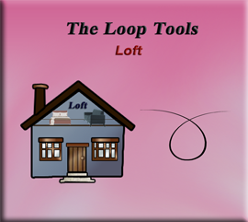

# Why are we on Loft instead of G Stretch?

I know you are probably wondering what happened to that last lesson on G Stretch, and why are we skipping it and going straight on through to this tutorial on the Loft tool. Well although, Loop tools are a fantastic add-on in most cases, because it is a 3rd party tool, and not maintained by the Blender team itself, things can get a bit buggy when Blender decides to massively update some things, and sometimes these third parties like, the Loop Tool’s company, has not quit got it all-together yet caught up.

This is the case with G Stretch. G stretch relies enormously on the Annotation tool, or the G pencil tool, for it to work. This is a difference between this tool and the other tools in this arsenal. So, problem lies in the fact that Blender has tremendously updated these drawing tools, and so now Loop tool does not any longer know how to connect to them. This is a problem, and the reason why (for now) we are skipping over the G stretch tool, and going on to the next tool, which is: Loft.

# What is the Loft Tool?

The Loft tool is kind of like bridge and it will take some mesh shapes, and attempt to make a bridge, or loft between the objects. The loft tool and the bridge tool are very similar. They are so similar that they will share the same Last Operation dialog box at the bottom of the screen. Be careful, because when you are changing the settings for one, you are changing the settings for bridge tool, which as you remember is the first tool in this Loop tool treasure chest.

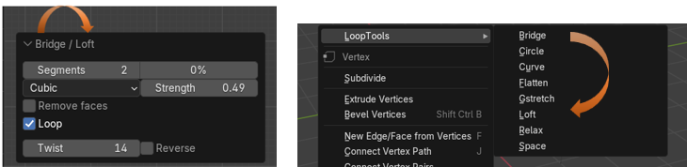

# Prepping the Objects

Let’s start by adding some Circles to the viewport, so we have something to work with

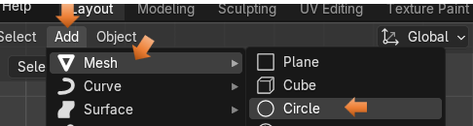

If you added it in front view, you will need to rotate the object 90° on the X axis to make it stand up. Make sure you are in Rotation and not in Location or your object will go flying off of the screen.

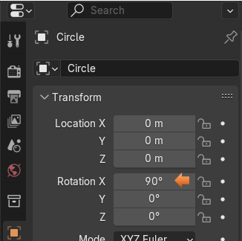

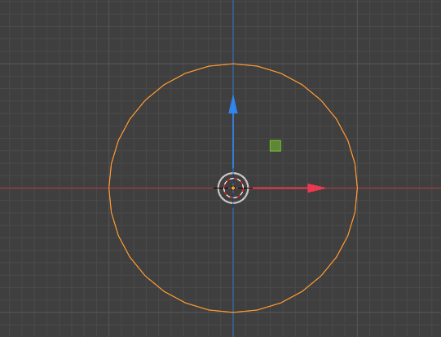

Hit the 3 key on the numpad and turn this circle, so we can look at it from its side view. We want to then hit the Shift – D key to duplicate your circles. Since this Loft tool can be very finicky, we will want to hit the M key to move the object and then hit the Y key to constrain the movement to the Y axis. We are looking at these circles from the side, so they should look like thin straight lines. But we kept them in line.

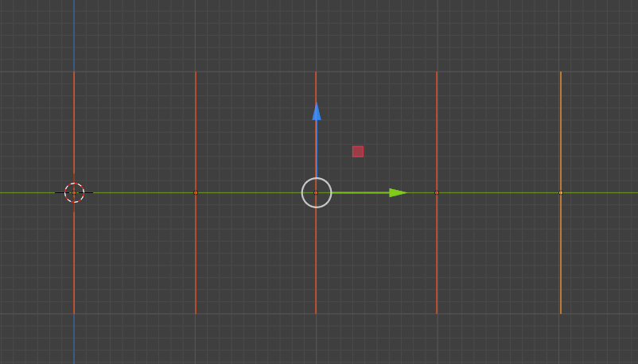

# Joining Objects Together

This is one of the got-cha things in Blender, whereas if you do not do it, you will never get anywhere except driven crazy.

When you are working with multiple objects in Blender, they MUST be joined together before leaving object mode. So, while still in Object mode, make sure that you select all of the objects that you want to work with. Then hit CTRL-J and join them together.



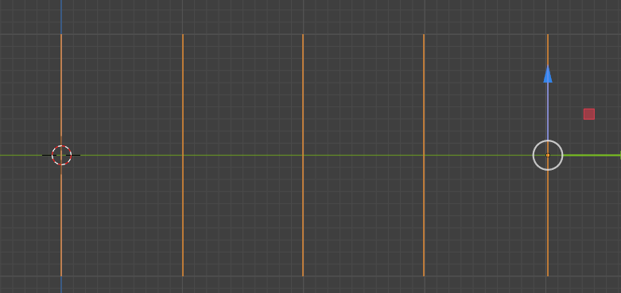

You will know they are joined together, because these circles will all turn orange. Instead of one being orange, and the rest of them being a red color.

# Starting to Loft the Objects

Now we can enter Edit Mode

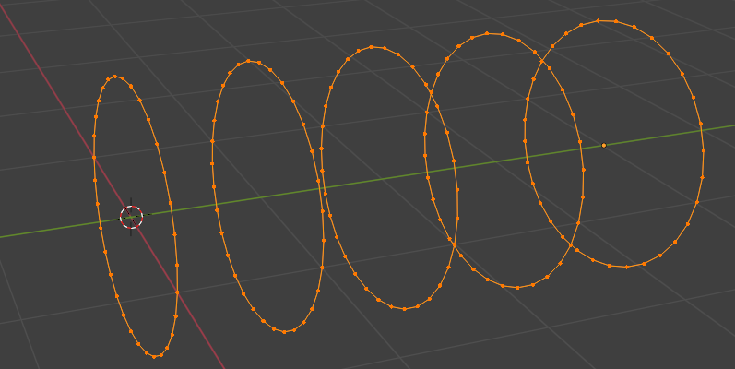

With all of the circles selected, right click and select Loft from the Loop Tool section.

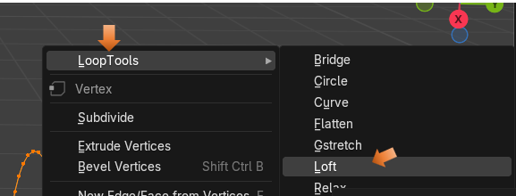

This is what I started with, but yours might look different depending on what your settings have started out with for this tool. It will usually give us (by default) some weird settings, and we will need to change them.

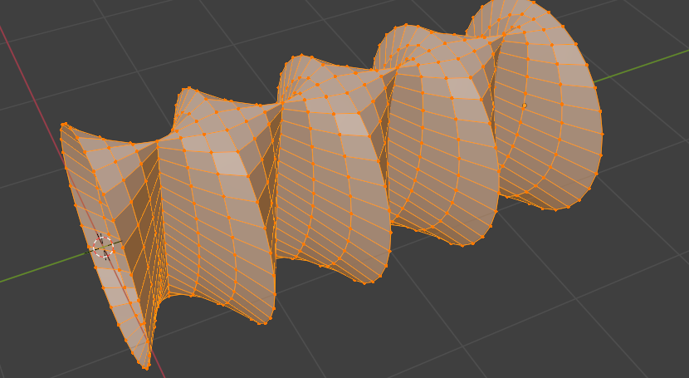

This is the settings that I was given, and this is why things are weird.

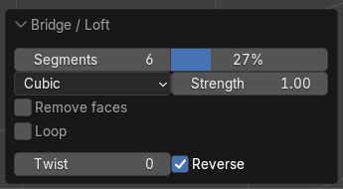

We want to change these settings to this. Unchecking that Reverse checkbox can really make a difference.

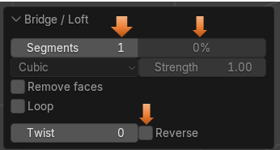

Now it looks like this

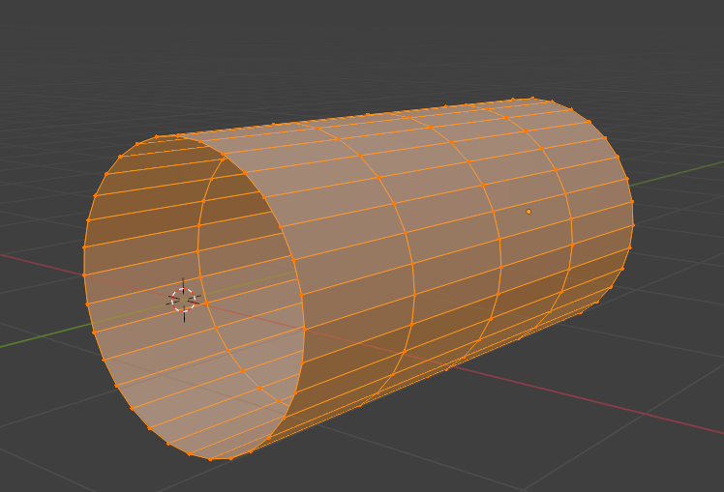

Once we get it straightened out, you can start to add more segments to it.

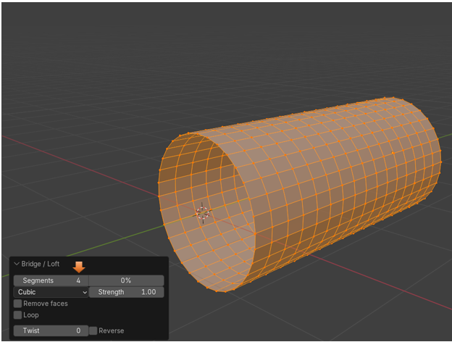

You can even try and twist it.

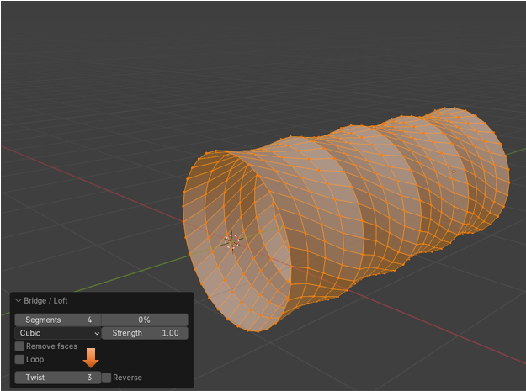

But if you throw in that Reverse check box, you got a mess.

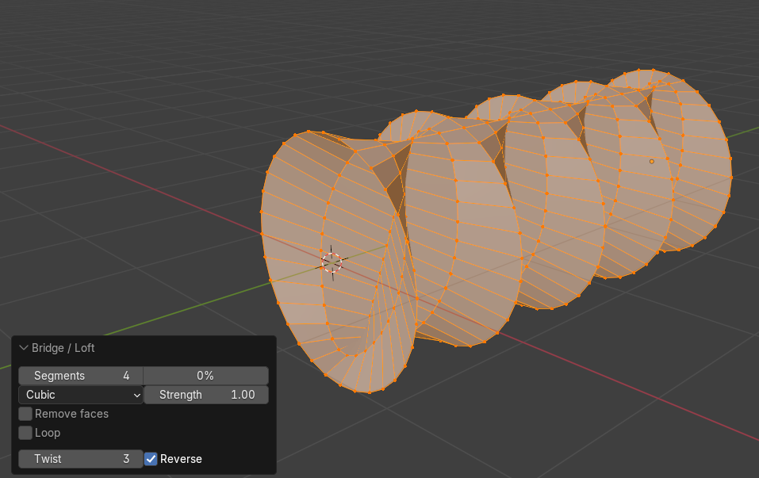

But, as you can see from this next image, these following settings seem to be the best. We could even go with less segments and get better optimization. Then if we try to animate it, it would react faster. Especially if your scene was quite complex, with other objects that weighed your animation down.

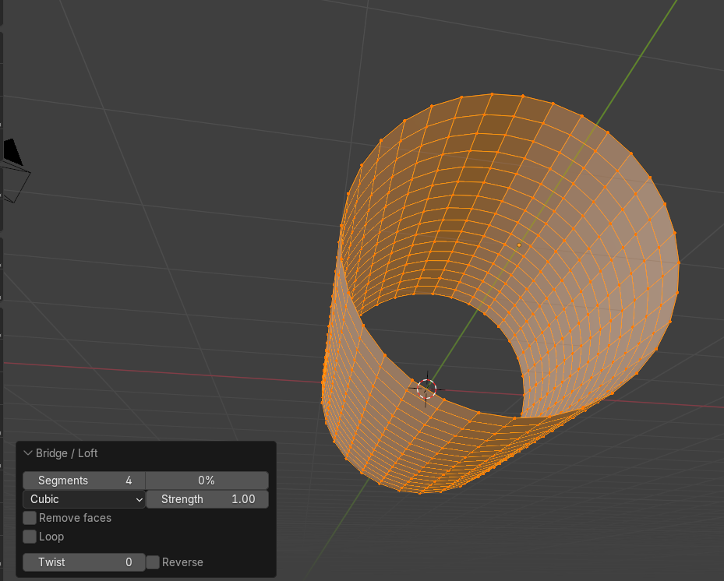

So, I guess that is about it for this one. Start lofting a few of your own objects and see what you can come up with.